HANOI UNIVERSITY OF SCIENCE AND TECHNOLOGY
School of Information and communications technology

Software Requirement Specification
Version 1.2

AIMS System
Subject: ITSS Software Development

Group 25
Đặng Hoàng Sơn -20235994
Ngô Đức Huy - 20235946
Nguyễn Hoàng Trung Kiên - 20235960
Lê Kế Đức - 20235912
Bùi Doãn Khang - 20235950

Table of content

Table of content 1
1 Introduction 2
1.1 Objective 2
1.2 Scope 2
1.3 Glossary 2
1.4 References 3
2 Overall Description 4
2.1 Survey 4
2.2 Overall requirements 4
2.3 Business process 5
3 Detailed Requirements 7
3.1 Use case 1 8
3.2 Use case 2 11
3.3 Use case 3 14
3.4 Use case 4 17
3.5 Use case 5 18
4 Supplementary specification 24
4.1 Functionality 24
4.2 Usability 24
4.3 Reliability 25
4.4 Performance 25
4.5 Supportability 25
4.6 Other requirements 25

Introduction

Objective
The main objective of this Software Requirements Specification (SRS) document is to provide a comprehensive architectural overview and detailed functional/non-functional requirements for the AIMS (An Internet Media Store) software. This document serves as the primary reference for the development team, software architects, software testers, and project managers to design, implement, and verify the system objectives

Scope
- Name: AIMS (An Internet Media Store).
- Brief Description: AIMS is a 24/7 e-commerce application (website or desktop app) designed to facilitate the buying and selling of physical media products, initially including books, newspapers, CDs, and DVDs.. It allows customers to browse, cart, and purchase items without logging in, while providing secure administrative portals for Product Managers and Administrators to manage inventory, orders, and staff roles.
- Goals & Benefits: The system aims to provide a highly available and fast shopping experience. It is engineered to serve up to 1,000 customers simultaneously without significant performance degradation, operate continuously for 300 hours, and ensure a maximum response time of 2 to 5 seconds.
- Functional scope:
  - The development of a comprehensive product management toolset supports CRUD operations and change history tracking, combined with a flexible inventory control system that enables automatic updates.
  - For customers, the system provides an optimal shopping experience with advanced search, product filtering, and shopping cart management features, integrated with automatically calculating fees and VietQR and PayPal payment gateways.
  - The system maintains high integrity and security through the principle of least privilege and data protection standards, logging of sensitive actions, and control over the entire order lifecycle from approval to automated refund mechanisms (for PayPal).
- Out of functional scope:
  - The system only supports physical media products and does not yet support other types of products.
  - SMS or push notification methods are not yet supported.
  - The system does not process automatic refunds for transactions via VietQR.

Glossary
No | Term | Explanation | Example | Note
1 | AIMS | An Internet Media Store. | N/A | The core software product.
2 | VAT | Value-Added Tax. | 10% VAT | Excluded from the original value and current price.
3 | Physical Media | Tangible media products supported by the store. | Books, CDs, DVDs, Newspapers | Other types may be supported in the future.
4 | PayPal Sandbox | A testing environment for credit card payment integration. | Mock credit card transaction | Used for demonstration purposes.
5 | VietQR | An API for generating and processing QR code payments. | VietQR Sandbox | The default payment method.
6 | SRS | Software Requirements Specification. A detailed document acting as a contract between stakeholders and developers, outlining the intended purpose, features, functionality, and constraints of a software application | This document
7 | API | Application Programming Interface is a set of rules and protocols that allows two or more software applications to communicate and exchange data with each other. | VietQR and PayPal API
8 | CRUD | Create, Read, Update, Delete | CRUD Product
9 | Webhook / Callback | Mechanisms for event-driven communication between systems, typically via HTTP POST requests. | VietQR payment callback
10 | Response time | Response time refers to the amount of time it takes for a system to respond to a user's request or input. | 100ms

References
AIMS: An Internet Media Store - Problem Statement v3.1 (Lecturer: NGUYEN Thi Thu Trang)

Overall Description
AIMS is an e-commerce platform designed with simplicity and performance in mind. It separates the customer-facing shopping experience from the internal management workflows. To streamline purchasing, the customer interface requires no authentication. In contrast, the internal system requires role-based access control for administrative and catalog management tasks

Survey
List of Actors and Descriptions:
- Customer A user who browses the catalog, manages their shopping cart, and places orders.
- Product Manager A staff member responsible for maintaining the product catalog (CRUD operations, stock adjustments), reviewing (approving/rejecting) pending orders, querying product operation histories and manually refunding to customers.
- Administrator: A staff member who manages internal user accounts, assigns roles, and handles security actions like blocking users or resetting passwords.
- VietQR: A payment gateway that processes the default QR code payment method.
- Paypal Sandbox: A payment gateway that processes alternative credit card payments and handles automated refunds

Overall requirements
The functional scope of AIMS is defined through the list of Use Cases interacting directly with each Actor, as illustrated in the Use Case Diagram:
2.2.1. Customer Use Cases
- Search Products: The customer searches for products using titles or categories.
- View Product Details: The customer views all the detailed information of each product.
- CRUD Product in cart: The customer can add products, remove products, or change the quantity of products in the cart.
- Place Order: The customer proceeds to checkout.
- Pay Order: The default checkout process interacting with the VietQR system. If the customer chooses an alternative method, this flow extends to Pay Order By Credit Card, which interacts with the Paypal Sandbox.
- View order information: The customer views all information about the order
- Cancel Order: Initiates the cancellation of a pending order.
2.2.2. Product Manager Use Cases
- Login & Change Password: The product manager needs to log in to access features and can change their password whenever they want.
- CRUD Products: The product manager can add, view, edit, or delete products to manage the inventory.
- Query CUD Products histories: The product manager can query the stored history of product additions, edits, and deletions.
- Review Pending Orders: The product manager views details of pending orders and can approve or reject them.
- Manually Refunding Orders:The PM will contact the customer and transfer funds outside the system (so not included in the ucd) in some cases.
2.2.3. Administrator Use Cases
- Login & Change Password: The administrator must log in to access administrative features and can change their password.
- Manage Users: The administrator can create, view, deactivate, block, or unblock user accounts, and assign user roles.
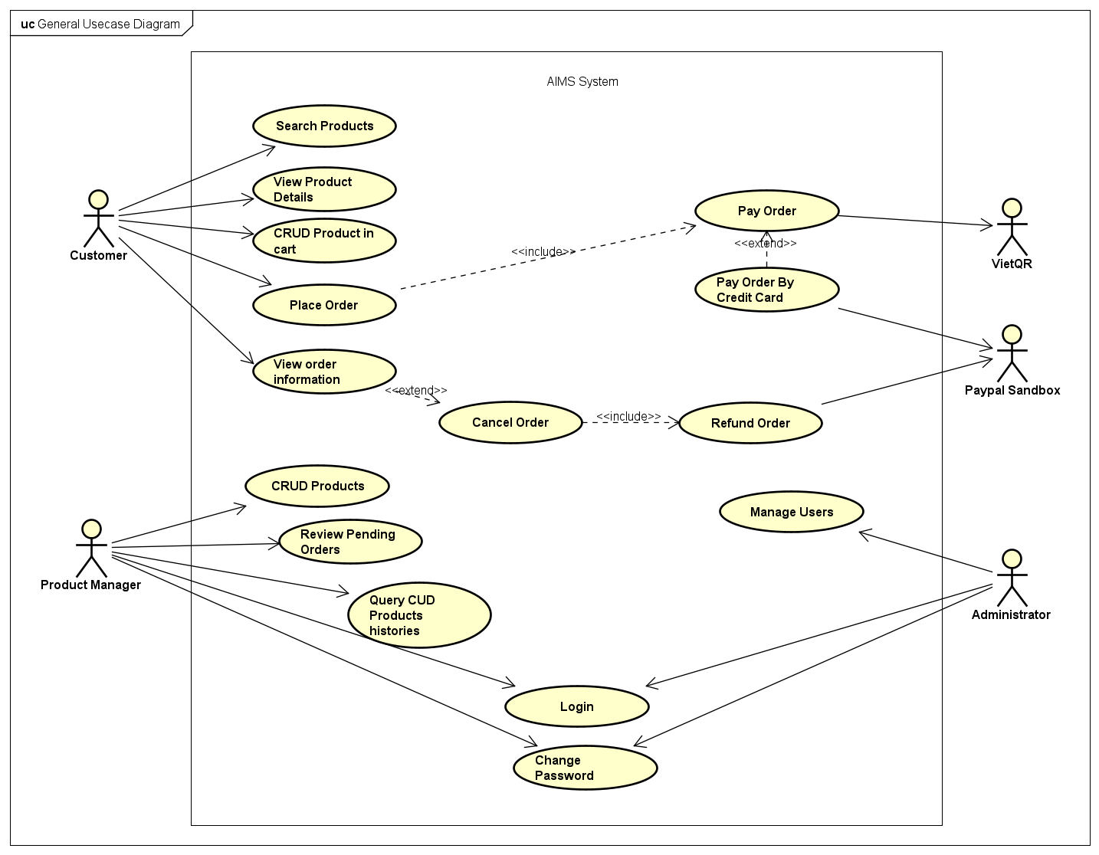

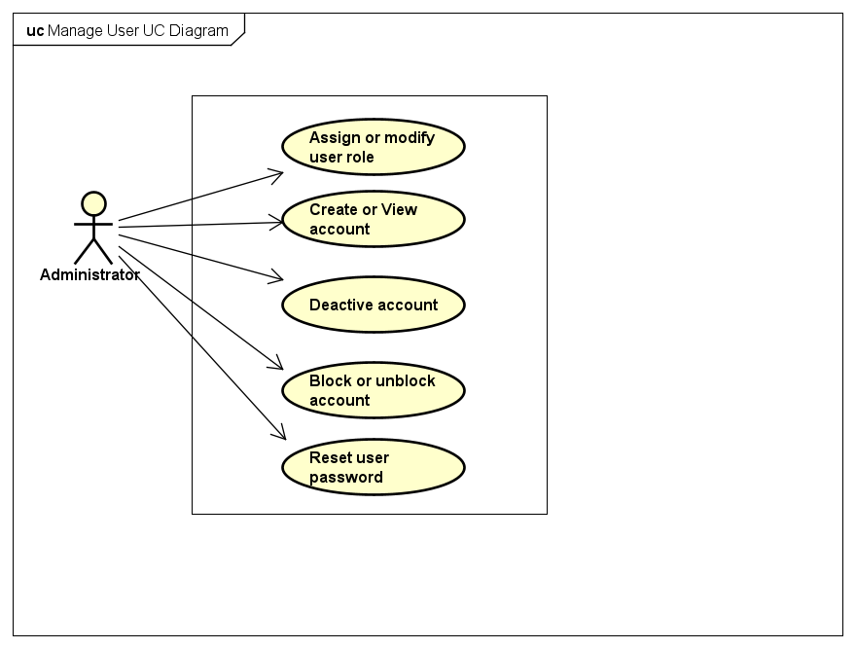

Business process
2.3.1. The Selling Process
- The Customer executes Search Products and View Product Details to explore the catalog.
- The Customer manages their selections via CRUD Product in cart.
- The Customer initiates Place Order, which transitions into Pay Order (VietQR) or optionally extends to Pay Order By Credit Card (Paypal).
- Post-purchase, the Customer can use View order information to track their order status.
- If the order is not yet approved, the Customer can trigger Cancel Order. The system then executes Refund Order to automatically return the full amount via Paypal Sandbox.
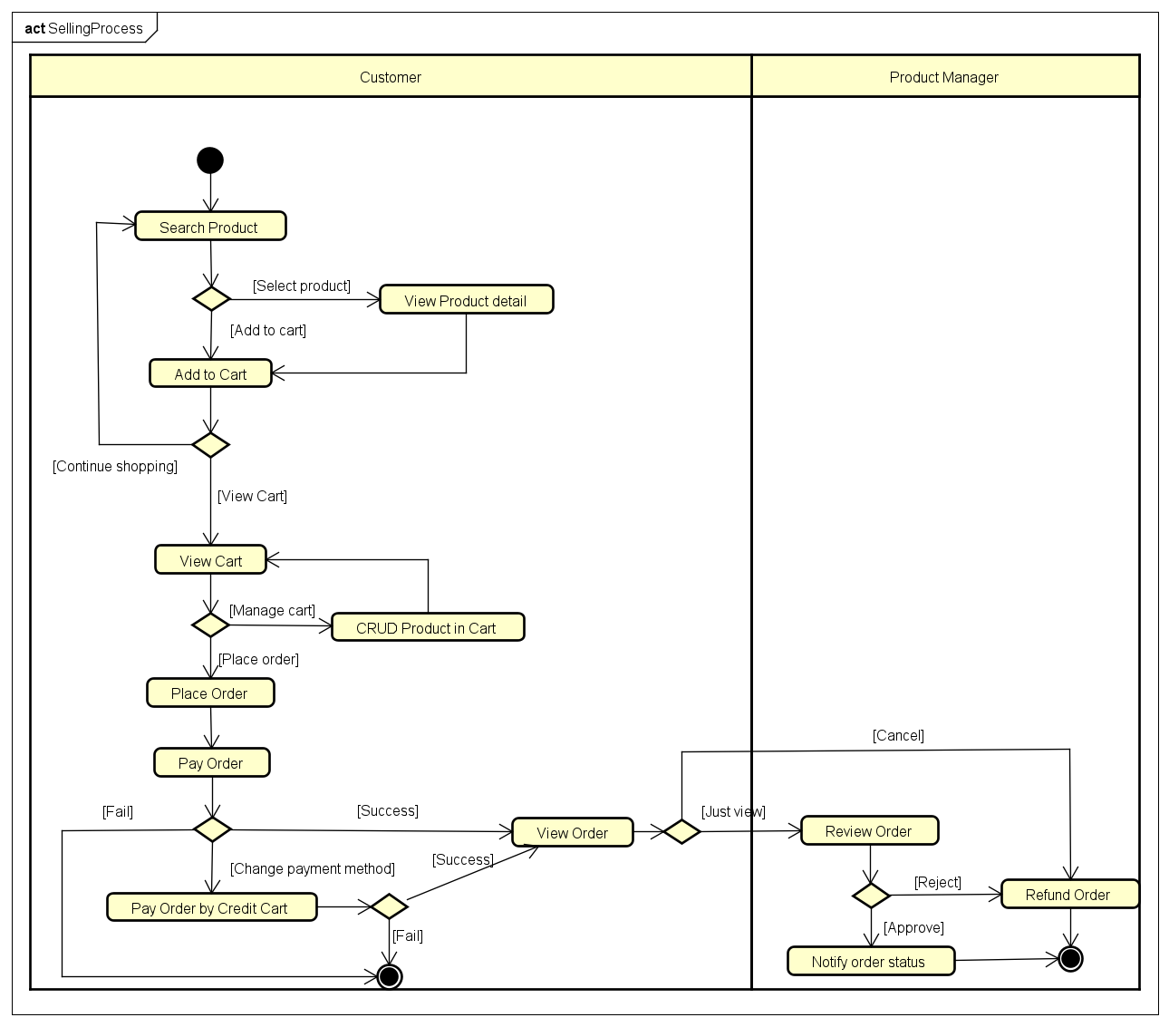
2.3.2. The Inventory & Order Fulfillment Process
- The Product Manager completes Login.
- To manage stock, they execute CRUD Products and can monitor internal changes via Query CUD Products histories.
- To process sales, they execute Review Pending Orders to evaluate and either accept or reject the orders.
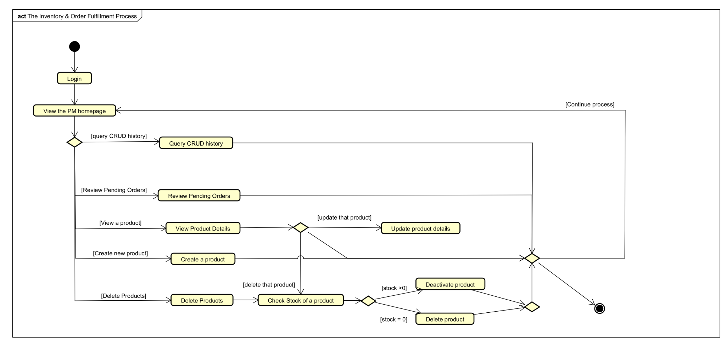
2.3.3. The Administration Process
- The Administrator completes Login.
- They execute Manage Users to securely maintain staff credentials and access rights across the platform.
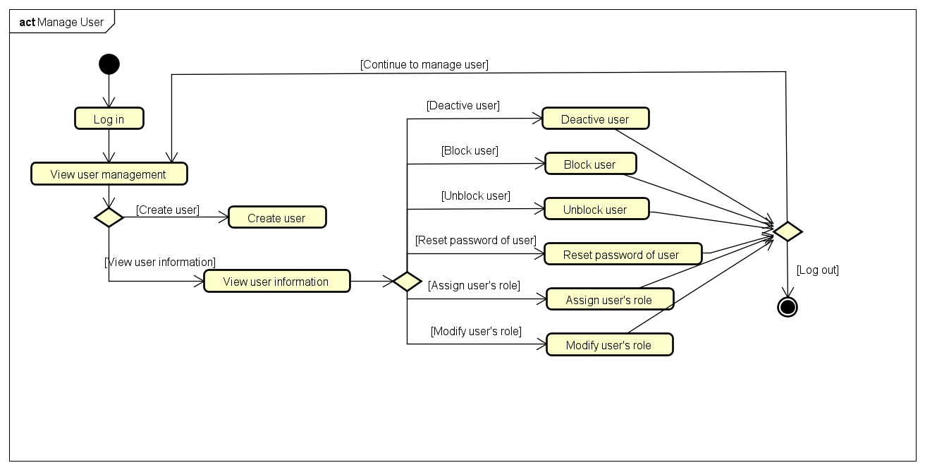

Detailed Requirements

Use case 1
Use Case “View Product Detail”
- Use case code
UC001
- Brief Description
This use case describes the interaction between the Customer / Product Manager and the AIMS system when the actor wants to view the detailed information of a product that has already been displayed in the product list.
- Actors
  - Name of Actor 1
Customer
  - Name of Actor 2
Product Manager
- Preconditions
The AIMS system is operating normally.
The selected product has already been displayed in the product list screen, search results screen, or product management screen.
In the case of the Product Manager, the actor has logged in and has permission to access the product management function.
In the case of the Customer, no login is required.
- Basic Flow of Events
- The actor is viewing a list of displayed products.
- The actor selects a product to view its details (see Table A).
- The system receives the request and retrieves the selected product data.
- The system displays the full product details of the selected product (see Table B).
- The use case ends.
- Alternative flows
- Input data
Table A-Input data of UC ViewProductDetail
No | Data fields | Description | Mandatory | Valid condition | Example
 | Selected product | The product selected by the actor for viewing details | Yes | The product has already been displayed in the system | Book A
- Output data
Table B-Output data of UC ViewProductDetail
No | Data fields | Description | Display format | Example
 | Title | Product title | Text | One piece
 | Category | Product category | Text | Book
 | General description | General description of the product | Paragraph text | Book
 | Height | Product height | Number/Text | 20 cm
 | Width | Product width | Number/Text | 15 cm
 | Length | Product length | Number/Text | 3 cm
 | Weight | Product weight | Number/Text | 0.5 kg
 | Barcode | Product barcode | Numeric string | 012345678
 | Original value | Original value of the product (without 10% VAT) | Currency ( VNĐ) | 120 000 VNĐ
 | Current price | Current selling price of product ( without 10% VAT) | Currenct( VNĐ) | 100 000 VNĐ
 | Author | Author of the book | Text | Nguyen Nhat Anh
 | Cover type | Type of book cover | Text | Paperback
 | Publisher | Publisher of the book/ newspaper | Text | Kim Dong
 | Publication date | Date of publication | Date | 15/03/2026
 | Number of pages | Total number of pages of the book | Number | 250
 | Language | Language of the product | Text | Vietnamese
 | Genre | Genre of the product | Text | Fiction
 | Editor-in-chief | Editor-in-chief of the newspaper | Text | Le Anh Dat
 | Issue number | Issue number of the newspaper | Number | 123
 | Publication frequency | Publication frequency of the newspaper | Text | Weekly
 | ISSN | ISSN code of the newspaper | Text | 1234-5678
 | Sections | Section of the newspaper | Text | Business
 | Artists | Artists of the CD | Text | Jack
 | Record label | Record label of the CD | Text | MTP entertainment
 | Track list | List of track, each with title and length | List | Track 1 – 2:34
 | Release | Release date of the CD/DVD | Date | 14/03/2026
 | Disc type | Type of DVD disc | Text | Blu-ray
 | Director | Director of the DVD | Text | Chan Buu Loc
 | Runtime | Runtime of the DVD | Text | 120 minutes
 | Studio | Studio of the DVD | Text | CDA studio
 | Subtitles | Subtitles of the DVD | Text | Vietnamese

- Postconditions
- The actor has viewed the full detailed information of the selected product.
- No system data is changed.
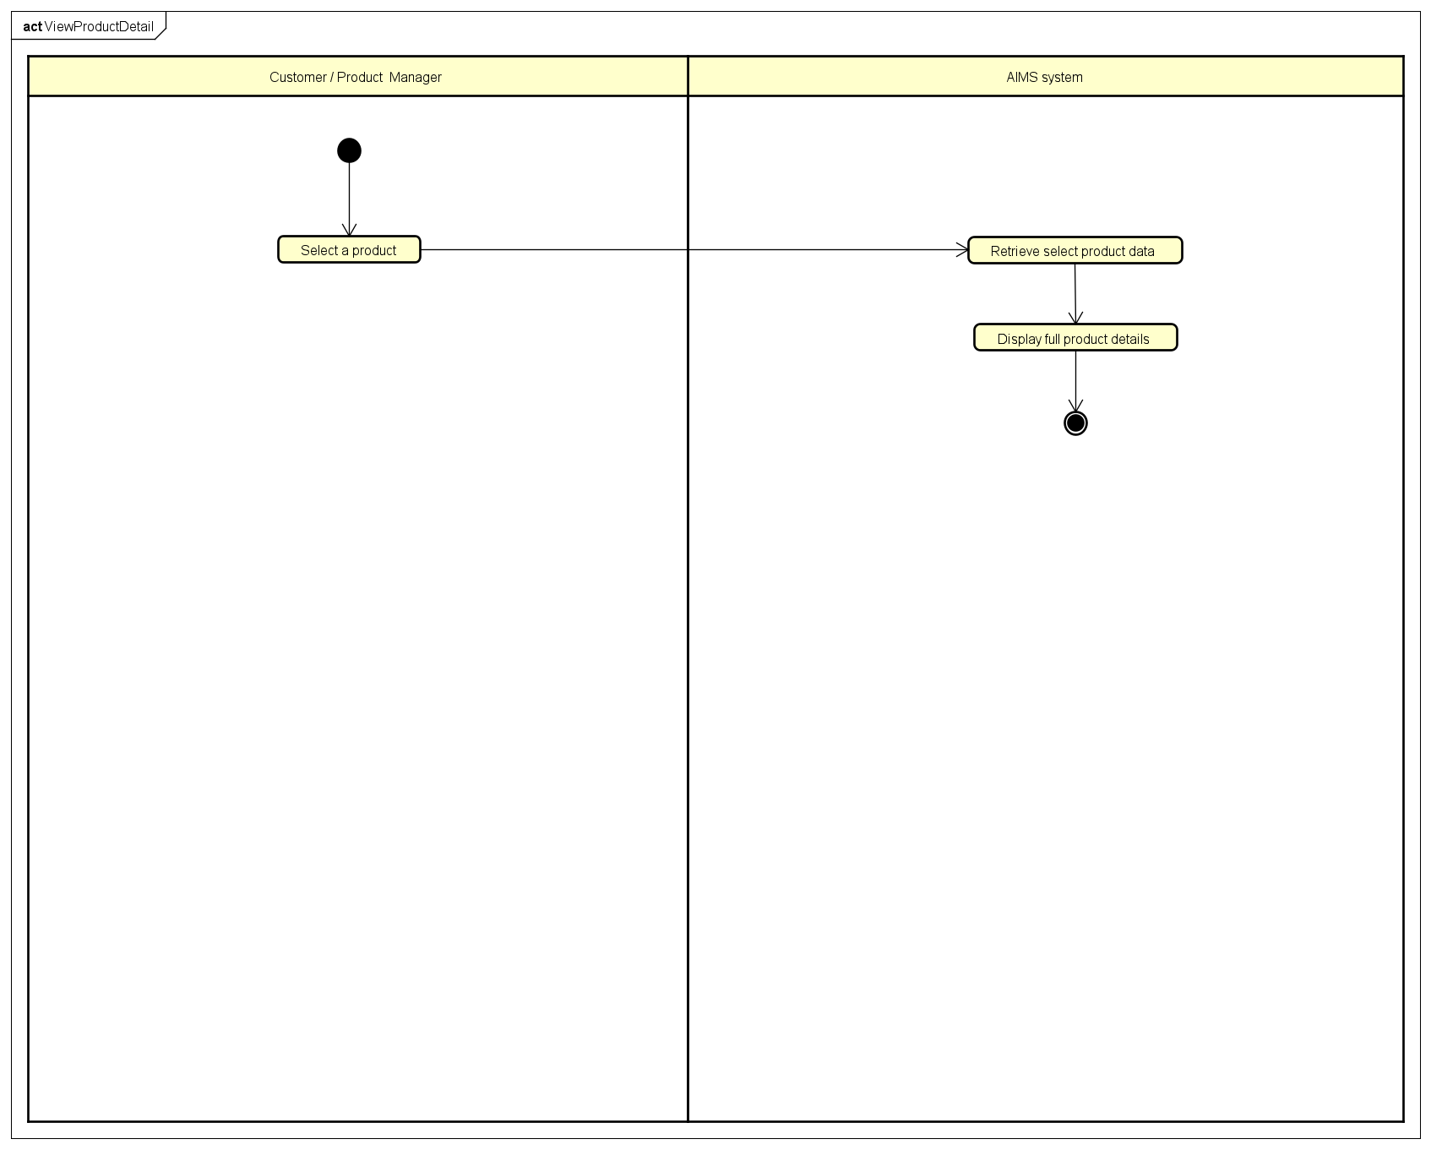

Use case 2

Use Case “Place Order”
- Use case code
UC002
- Brief Description
This use case describes the interaction between Customer and Aims system when Customer places an order for products in the cart and proceeds to payment.
- Actors
  - Customer
- Preconditions
  - The Aims system is running normally
  - Products in the cart exist in the system
  - There is at least one item in the cart.
- Basic Flow of Events
- Customer requests to place an order from the cart
- The system checks whether the available stock is sufficient to fulfill the customer’s demands
- If the stock is sufficient, the system displays the delivery information form together with the cart information
- Customer enters and submits delivery information
- The system validates the delivery information and asks the customer to update if in case any required field is blank or invalid
- The system call Pay Order
- After successful payment, the system displays the general order information, including customer name, phone number, shipping address, province, and total amount, together with transaction information including transaction ID, transaction content, and transaction time
- The system clears the cart
- The system sets the order status to Pending Processing
- The system sends the invoice and payment transaction information to the customer’s email
- The system records the payment transaction and successful order information

- Alternative flows
Table N-Alternative flows of events for UC Place order

No | Location | Condition | Action | Resume location
1. | At Step 2 | One or more products in the cart do not have sufficient stock to fulfill the customer's requested quantity | ▪ The software notifies the customer that some products in the cart are out of stock or insufficient. Customer is required to update the cart | Use case ends and returns to View Cart
2. | At Step 5 | The delivery information entered by the customer is incomplete or invalid | ▪ The system displays an error message indicating the invalid or missing information. The customer is requested to re-enter valid delivery information | Step 4: Enter delivery info
3. | At any step | The customer wants a previous screen or exits the ordering process | ▪ The system saves the current cart information  ▪ The ordering process is canceled or paused | Use case ends
4. | At step 6 | Payment fails or the customer cancels the payment while it is in process | ▪ The system displays a message that Payment is unsuccessful  ▪ The customer may retry the payment or modify the order | Step 5: Check info again and continue with Step 6

- Input data
Table A-Input data of place order
No | Data fields | Description | Mandatory | Valid condition | Example
1. | Receiver Name | Name of the person who will receive the order | Yes | Not empty | Bùi Doãn Khang
2. | Phone Number | Phone number of the receiver used for delivery contact | Yes | - Not empty  - Contain 10 digits and start with ‘0’ | 0123456789  0123 456 789
3. | Province/City | Province or city where the order will be delivered | Yes | Must be selected from the list of supported provinces/cities in Vietnam | Hà Nội  Hồ Chí Minh city
4. | Address | Detailed address where the order will be delivered | Yes | Not Empty | 1 trần đại nghĩa street, hà nội
5. | Delivery Notes | Some notes for the delivery process. | No | Not exceed 255 characters | Please call before delivery or send message

- Output data
Table B-Output data of Place Order
No | Data fields | Description | Display format | Example
1. | Product Title | Title of the media product displayed in the invoice | Text | Books: master machine learning
2. | Product Price (no VAT) | Price of a product in the order (excluding VAT) | Positive number with thousands separator | 120,000
3. | Quantity | Quantity of the product in the order | Positive integer | 2
4. | Subtotal | Total price for each product (Product Price × Quantity) | Positive number with thousands separator | 1,000,000
5. | Total(exclude VAT) | Total price of all products in the order before VAT is applied | Positive number with thousands separator | 5,000,000
6. | Total (include VAT) | Total product price including VAT | Positive number with thousands separator | 5,200,000
7. | Shipping fee | Shipping fee calculated by the system based on delivery address and product weight | Positive number with thousands separator | 40,000
8. | Total Payment | Total payment amount including product price (include VAT) and delivery fee | Positive number with thousands separator | 5,240,000
9. | Receiver Name | Name of the person receiving the order | Text | Bùi Doãn Khang
10. | Phone Number | Phone number of the order receiver | Numeric Text | 0123456789
11. | Delivery Address | Delivery address of the order | Text | 1 trần đại nghĩa street, hà nội
12. | Province/City | Province or city of the delivery address | Text | Hà Nội
13. | Transaction ID | ID of the payment Transaction | Numeric Text or/and Text | ABC123
14. | Transaction Content | Description or content of the payment transaction | Text | Payment for ABC123
15. | Transaction Datetime | Date and time when the payment transaction occurred | dd/MM/yyyy HH:mm:ss | 1/1/2026 12:30:00

- Postconditions
Success Postcondition:
● The place order state is successful
● A new order is created in the system
● The order status is set to Pending Processing
● The system records the order information and payment transaction information
● The customer’s cart is cleared
● The system sends the invoice and payment transaction information to the customer’s email
Failure Postcondition
● No order is created in the system
● No payment transaction is recorded
● The products remain in the customer's cart so that the customer can modify the order or attempt payment again
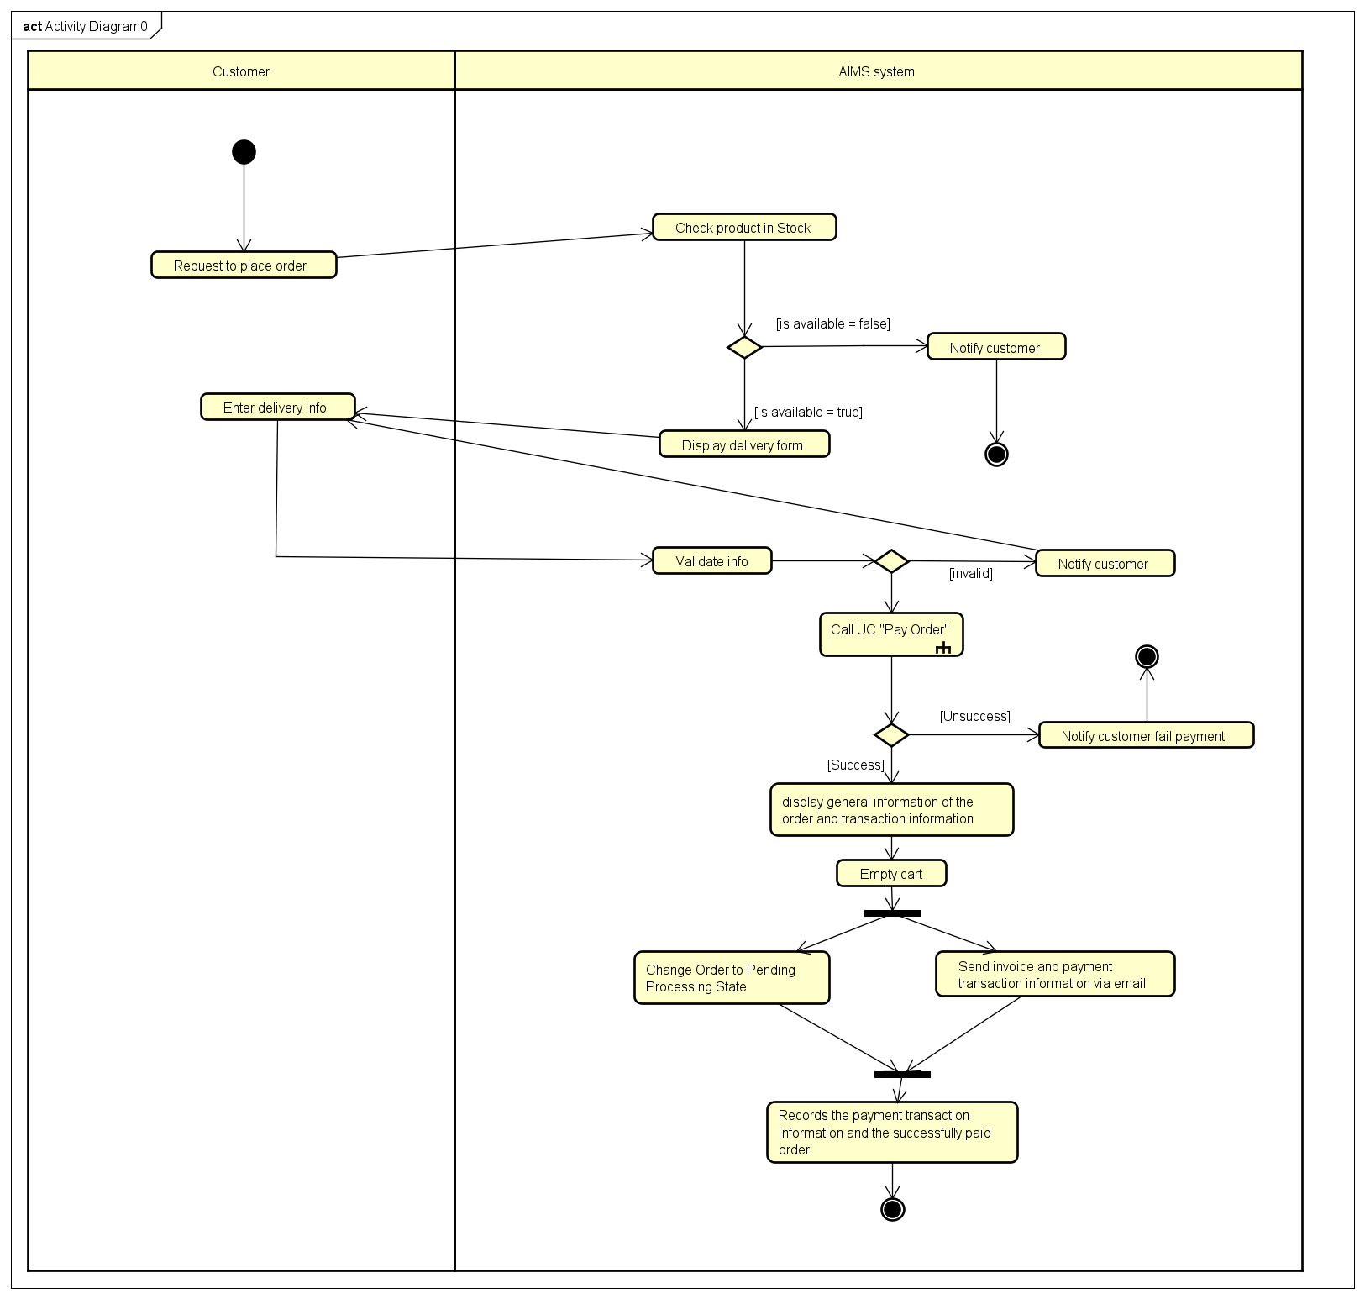

Use case 3
Use Case “Pay Order”
  - Use case code: UC003
  - Brief Description: This use case involves the integration of payment using the VietQR method, allowing customers to pay for physical media products (books, newspapers, CDs, DVDs) via a QR code.
  - Actors
- Customer: The user purchasing physical media.
- VietQR Service: The external system providing the API for QR generation and transaction sync.
  - Preconditions
- The system has calculated the current price of products.
- The system has created connection to VietQR.
- The customer has placed an order for the products in their cart with delivery information.
  - Basic Flow of Events
- The system displays the invoice information.
- The customer selects pay the order.
- The system calls the VietQR Payment API and send information (See Table A).
- VietQR System generates a dynamic QR code based on the order details and send to the system (See Table B).
- The system displays the generated QR code and invoice information to the customer (See Table C).
- The customer completes the payment using the QR code.
- VietQR system handles the transaction and sends result to the system.
- The system returns the payment transaction result and information to the calling use case ("Place Order").

  - Alternative flows
No | Location | Condition | Action | Resume location
 | At Step 2 | If customer changes payment method | The system changes to Paypal method | Call Usecase “Pay Order by Credit Card”
 | At Step 3 | If the system cannot connect to the VietQR system | The system displays error message. | Use case ends
 | At Step 6 | If QR code is invalid or expired | The system displays the message "Payment failed or overdue". | Resumes at step 1
4. | At Step 6 | If the customer wants to cancel the payment transaction | The system displays the message “Cancelled Transaction”. | Resumes at step 1
5. | At Step 7 | If the transaction is failed | The system notifies the failure | Resumes at step 1
  - Input data
Table B
No | Data fields | Description | Mandatory | Valid condition | Example
 | QR Link | The URL contains a QR code image automatically generated by the VietQR system. | Yes | Must be a valid HTTPS URL | https://img.vietqr.io/image/mb-1234567890-compact.png?amount=500000&addInfo=PAY98765

  - Output data
Table A
No | Data fields | Description | Display format | Example
 | BankCode | Recipient's bank | Required, String | MB
 | BankAccount | Recipient's bank account | Required, String (Numeric characters only) | 99991112345
 | UserBankName | Recipient name | Required, String | NGO DUC HUY
 | TotalAmount | The actual amount of the order | Required, Integer, greater than 0 | 150.000
 | Content | The transfer details will be visible to the customer. | Maximum 19 characters, written continuously without spaces or accents, and no special characters. | ORD12345
 | OrderId | Transaction code for system to manage. | Required, String, Unique | ORD12345
Table C
No | Data fields | Description | Display format | Example
 | QR code | Code for scanning | Valid image code | 
 | Total amount | Total amount to be paid | Vietnamese Currency | 150.000 VNĐ
 | Delivery address | Delivery address for the order | Non-empty string | 123 P. Minh Khai, Hanoi
 | OrderID | ID of each order for system to manage. | Required, String, Unique | ORD12345

  - Postconditions
- The payment transaction is authorized and confirmed by the VietQR system. Transaction details (including Transaction ID, Transaction Datetime, and success status) are returned to the Use Case (Place Order) to continue the order recording flow.
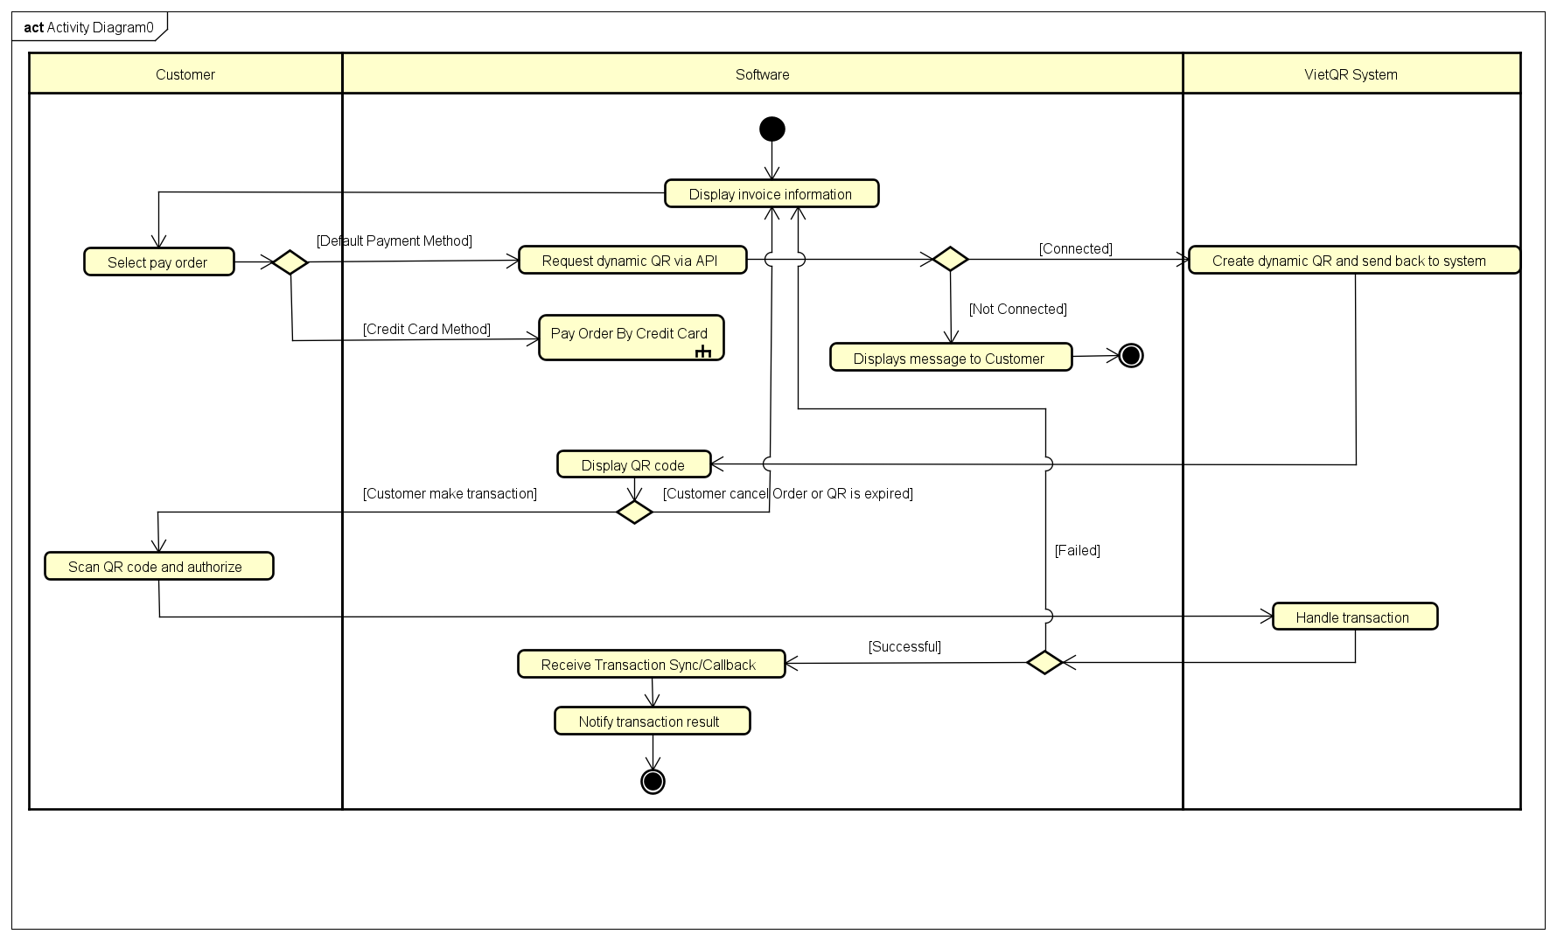
- If the payment is successful, the customer is notified and receives a bill detailed email. If it fails, nothing happens.

Use case 4

Use Case Pay Order By Credit Card
- Use case code
UC004
- Brief Description
This use case describes the interaction between the Customer, Paypal Sandbox System and AIMS System when the Customer wishes to pay for an order using a credit card.
- Actors
  - Customer
  - Paypal Sandbox System
- Preconditions
Customer in the Check Out page and choose the Credit Card Payment method
- Basic Flow of Events
1. The software display invoice information
2. The Customer selects the "Credit Card" payment option and clicks "Proceed to Payment".
3. The software displays the credit card payment form.
4. The Customer enters their credit card details (see Table A) and clicks "Submit Payment".
5. The software validates the input data locally and sends a payment authorization request to the PayPal Sandbox API.
6. The PayPal Sandbox processes the simulated transaction.
7. The software notifies the payment result.

- Alternative flows
Table N-Alternative flows of events for UC Place order

No | Location | Condition | Action | Resume location
 | At Step 5 | If the input data is incomplete or violates validation rules (e.g., invalid card length, expired date). | Software highlights the invalid fields.  Software displays a specific error message (e.g., "Invalid card number"). | Resumes at Step 3
 | At Step 5 | If the software fails to connect to the PayPal Sandbox API (timeout or server error). | Software logs the system error.  Software displays a "Gateway connection error. Please try again later." message. | Use case ends
 | At Step 6 | If the PayPal Sandbox API declines the test card (e.g., insufficient funds test card). | Software logs the failed transaction attempt.  Software displays a "Payment Declined" error message. | Resume at Step 2
- Input data
Table A - Input data of Credit Card
No | Data fields | Description | Mandatory | Valid condition | Example
 | Card Number | The 16-digit number on the front of the card. | Yes | Exactly 16 numeric digits. Must pass Luhn algorithm check. | 4111 1111 1111 1111
 | Expiration Date | The month and year the card expires. | Yes | Format MM/YY. Must be a future date. | 03/30
 | CVV | Card Verification Value (security code). | Yes | Exactly 3 or 4 numeric digits. | 123
- Output data
No | Data fields | Description | Display format | Example
1 | Payment Status | Current status of the payment transaction | Text message (Success/Failure/Cancelled) | "Success"

- Postconditions
The payment result is displayed successfully
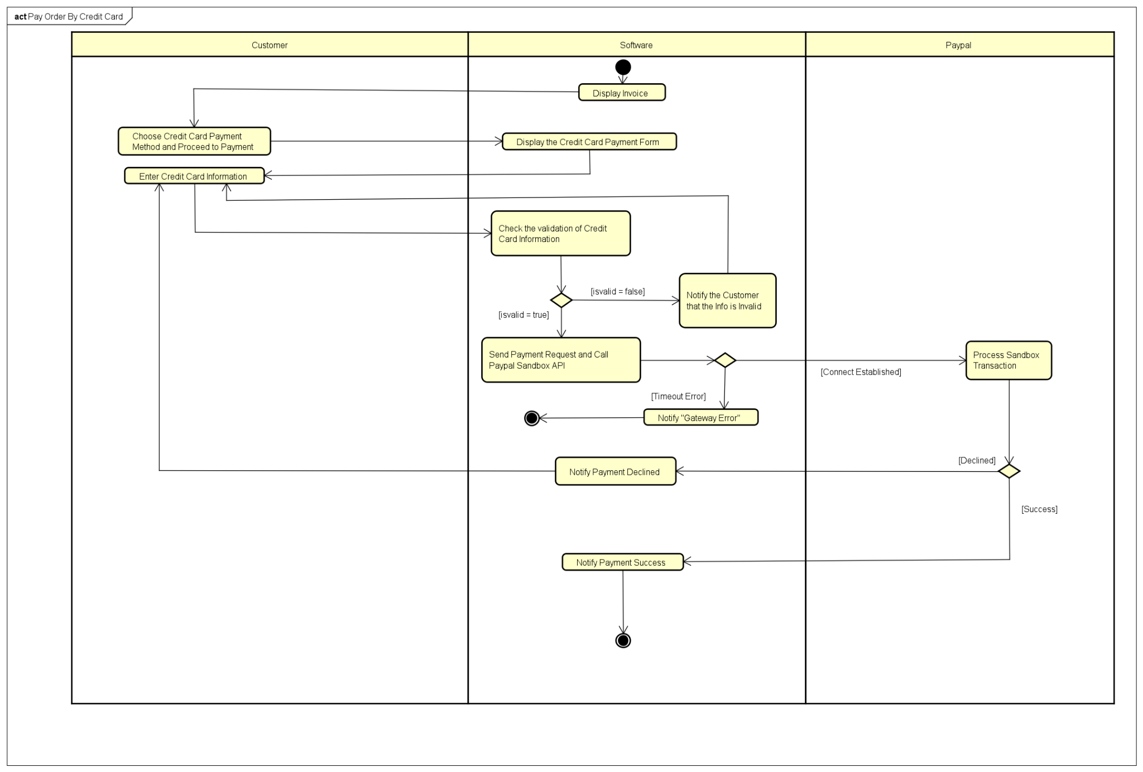

Use case 5

Use case “CUD Product”

Use Case: Create Product
1. Use Case Code
UC005-Create

2. Brief Description
This use case describes the interaction between the Product Manager and the AIMS system when the actor wants to add a new product to the system. The Product Manager can add an unlimited number of products per day, but only one product at a time. The system validates all input data — including type-specific fields, price constraints, and format rules — and ensures that all business rules are satisfied before completing the operation.

3. Actors
Product Manager

4. Preconditions
- The Product Manager has successfully logged in to the system.
- The Product Manager is currently on the product management screen.

5. Basic Flow of Events
1. The Product Manager selects the option to add a new product.
2. The system displays a blank product creation form.
3. The Product Manager selects the product type (Book, Newspaper, CD, or DVD). The form dynamically shows the required and optional fields for that type.
4. The Product Manager fills in all core information: title, general description, dimensions (height, width, length), weight, barcode, original value, and current price.
5. The Product Manager fills in the type-specific required fields and any optional fields.
6. The Product Manager enters the initial quantity in stock.
7. The Product Manager submits the form.
8. The system validates all input data against business rules (see Alternative Flows for violations).
9. The system saves the new product information to the database with status set to 'active'.
10. The system records an entry in the product addition history log.
11. The system displays a success notification. The form is reset, allowing the Product Manager to add another product if desired.
12. The use case ends.

6. Alternative Flows
- Missing Required Field: If any mandatory field is left blank upon submission (Step 7), the system highlights the empty field(s) and displays a descriptive error message. No data is saved. Resume at Step 4 or Step 5.
- Invalid Input Format: If any field contains data in an incorrect format (e.g., incorrect date format, non-numeric value in a numeric field) (Step 8), the system notifies the Product Manager with a specific message indicating which field is invalid and why. No data is saved. Resume at Step 4 or Step 5.
- Duplicate Barcode: If the submitted barcode already exists in the system (Step 8), the system displays an error message indicating the barcode is already in use. No data is saved. Resume at Step 4.
- Price Constraint Violation: If the current price is not within 30% to 150% of the original value (Step 8), the system displays an error specifying the valid price range. No data is saved. Resume at Step 4.
- Negative or Invalid Stock Quantity: If the initial stock quantity is negative or non-integer (Step 8), the system displays an error message. Resume at Step 6.

7. Input Data
No | Data Field | Description | Mandatory | Valid Condition | Example
1 | Product Type | Category of the product to be added | Yes | Must be one of: Book, Newspaper, CD, DVD | Book
2 | Title | Name / title of the product | Yes | Non-empty text, max 255 characters | One Piece Vol. 1
3 | Barcode | Unique product identifier | Yes | Must be numeric.  Must not duplicate any existing barcode in the system. | 8935234512345
4 | General Description | Brief description of condition,  color, or return policy | Yes | Non-empty text | Brand new, sealed
5 | Dimensions | Height x Width x Length of the product | Yes | Three positive numbers (cm), e.g. H x W x L | 20 x 15 x 5 cm
6 | Weight | Physical weight of the product | Yes | Positive number (kg), e.g. 0.5 | 0.5 kg
7 | Original Value | Base value before VAT (10% VAT not included) | Yes | Positive integer (VND) | 100,000 VND
8 | Current Price | Current selling price before VAT (10% VAT not included) | Yes | Positive integer (VND).  Must be between 30% and 150% of Original Value. | 120,000 VND
9 | Initial Stock Quantity | Number of items available in stock at creation | Yes | Integer >= 0 | 50
10 | Book Details | Required: Author(s), Cover Type  (Paperback / Hardcover), Publisher,  Publication Date.  Optional: Number of Pages,  Language, Genre. | Yes (if Book) | Author: non-empty text.  Cover Type: Paperback or Hardcover.  Publisher: non-empty text.  Publication Date: valid date (dd/mm/yyyy). | Author: Eiichiro Oda  Cover: Paperback  Publisher: Shueisha  Date: 24/07/1997
11 | Newspaper Details | Required: Editor-in-Chief,  Publisher, Publication Date.  Optional: Issue Number,  Publication Frequency, ISSN,  Language, Sections. | Yes (if Newspaper) | Editor-in-Chief: non-empty text.  Publisher: non-empty text.  Publication Date: valid date (dd/mm/yyyy).  ISSN: 8-digit numeric (if provided). | Editor: John Smith  Publisher: VnExpress  Date: 23/03/2026  Section: Sports, Tech
12 | CD Details | Required: Artist(s), Record Label,  Genre, Tracks List  (each track: title + length).  Optional: Release Date. | Yes (if CD) | Artist: non-empty text.  Record Label: non-empty text.  Genre: non-empty text.  Each track must have a non-empty title and a positive duration.  Release Date: valid date (dd/mm/yyyy, if provided). | Artist: The Beatles  Label: Parlophone  Genre: Rock  Track 1: Come Together - 4:20
13 | DVD Details | Required: Disc Type (Blu-ray /  HD-DVD), Director, Runtime,  Studio, Language, Subtitles.  Optional: Release Date, Genre. | Yes (if DVD) | Disc Type: Blu-ray or HD-DVD.  Director: non-empty text.  Runtime: positive integer (minutes).  Studio: non-empty text.  Language: non-empty text.  Release Date: valid date (dd/mm/yyyy, if provided). | Type: Blu-ray  Director: James Cameron  Runtime: 192 min  Studio: 20th Century Fox

8. Output Data
No | Data Field | Description | Display Format | Example
1 | Success Notification | Displayed when all validations pass and the product is saved successfully. | Text message (green banner) | Product added successfully.
2 | Validation / Error Message | Displayed when any input field fails validation or a business rule is violated. The message specifies the field and the reason. | Text message (red inline or banner) | Barcode already exists.  Current price must be between 30,000 VND and 150,000 VND.  Publication Date format is invalid (expected dd/mm/yyyy).
3 | Product Summary | After successful creation, the system displays a summary of the newly created product for confirmation. | Structured read-only form | Barcode: 8935234512345 | Title: One Piece Vol. 1 | Stock: 50

9. Postconditions
- The new product is stored in the system database with status 'active'.
- The initial stock quantity is set as specified.
- An entry is recorded in the product addition history log (timestamp, Product Manager ID, product details).
- The Product Manager can immediately add another product (no daily limit on additions).

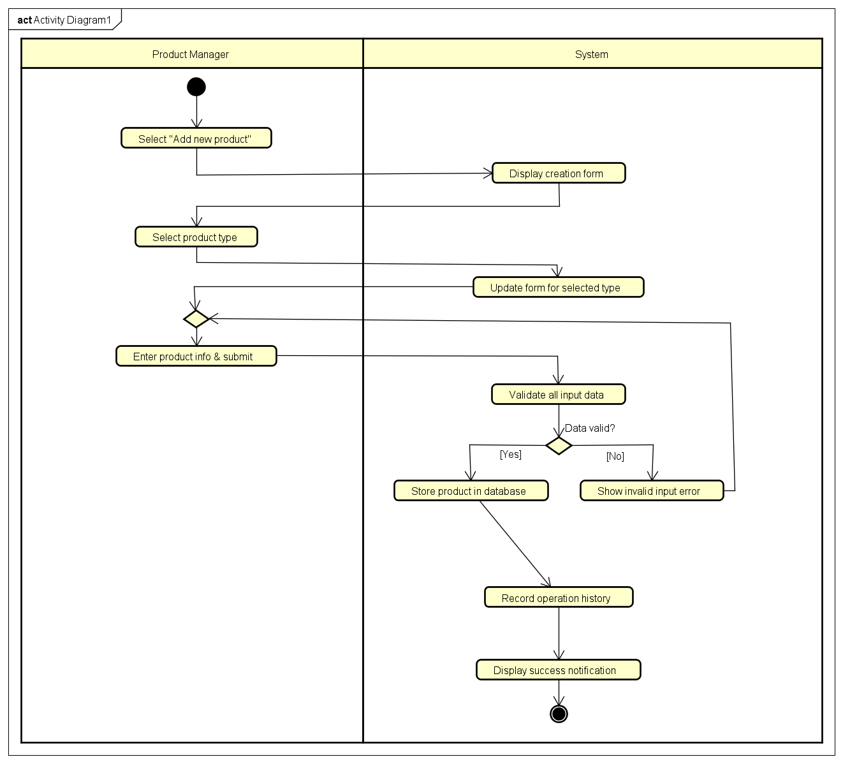

Use Case: Update Product
1. Use Case Code
UC005-Update

2. Brief Description
This use case describes the interaction between the Product Manager and the AIMS system when the actor wants to modify the information of an existing product, including its general details, type-specific attributes, price, and stock quantity. Only one product can be edited at a time. If the stock quantity is adjusted, the reason must be explicitly recorded. The system validates all input data before persisting any changes.

3. Actors
Product Manager

4. Preconditions
- The Product Manager has successfully logged in to the system.
- The Product Manager is on the product management screen.
- At least one product exists in the system.

5. Basic Flow of Events
1. The system displays the list of products (active and deactivated).
2. The Product Manager selects exactly one product to edit. The system retrieves and displays the current product information in an editable form.
3. The Product Manager modifies the desired fields.
4. If the Product Manager changes the stock quantity, the system requires the 'Reason for Stock Change' field to be filled in before submission.
5. The Product Manager submits the changes.
6. The system validates all modified fields against business rules (see Alternative Flows for violations).
7. The system saves the updated product information to the database.
8. The system records an entry in the product editing history log.
9. The system displays a success notification and refreshes the product detail view with the latest data.
10. The use case ends.

6. Alternative Flows
- Missing Required Field: If a mandatory field is cleared and left blank upon submission (Step 5), the system highlights the empty field(s) with a descriptive error. No changes are saved. Resume at Step 3.
- Invalid Input Format: If any field contains incorrectly formatted data (Step 6), the system displays a specific validation message indicating which field is invalid and the expected format. No changes are saved. Resume at Step 3.
- Price Constraint Violation: If the current price falls outside the range of 30% to 150% of the original value (Step 6), the system displays an error specifying the acceptable price range. No changes are saved. Resume at Step 3.
- Stock Changed Without Reason: If the stock quantity has been modified but the reason field is empty upon submission (Step 5), the system displays an error requiring the reason to be filled in before proceeding. Resume at Step 3.
- No Changes Detected: If the Product Manager submits the form without making any changes, the system informs the manager that no updates were made. The use case ends without saving.

7. Input Data
No | Data Field | Description | Mandatory | Valid Condition | Example
1 | Product ID (Barcode) | Identifier of the product being edited. Read-only; cannot be changed. | N/A (Read-only) | Must correspond to an existing product. | 8935234512345
2 | Title | Updated product name/title. | Yes | Non-empty text, max 255 characters. | Dragon Ball Vol. 1
3 | Product Type / Category | Updated category of the product. | Yes | Must be one of: Book, Newspaper, CD, DVD. | Newspaper
4 | General Description | Updated description of condition, color, or return policy. | Yes | Non-empty text. | Slight wear on cover
5 | Dimensions | Updated physical dimensions. | Yes | Three positive numbers (cm), e.g. H x W x L. | 21 x 15 x 15 cm
6 | Weight | Updated physical weight. | Yes | Positive number (kg). | 0.6 kg
7 | Original Value | Updated base value before VAT. | Yes | Positive integer (VND). | 200,000 VND
8 | Current Price | Updated selling price before VAT. | Yes | Positive integer (VND).  Must be between 30% and 150% of the (updated) Original Value. | 210,000 VND
9 | Stock Quantity | Updated number of items in stock. | Yes | Integer >= 0.  If value differs from current stock, field 'Reason for Stock Change' becomes mandatory. | 120
10 | Reason for Stock Change | Explicit reason when stock quantity is manually adjusted. | Conditional (required if stock is changed) | Non-empty text. Required only when stock quantity differs from the current value. | Removed 2 damaged items
11 | Type-Specific Details | Updated type-specific fields (same rules as in UC004-Create for the selected product type). | Yes | Must follow product type validation rules as defined in UC004-Create. | Artist: The Beatles; Genre: Rock

8. Output Data
No | Data Field | Description | Display Format | Example
1 | Success Notification | Displayed when all validations pass and the product is updated successfully. | Text message (green banner) | Product updated successfully.
2 | Validation / Error Message | Displayed when any input field fails validation or a business rule is violated, specifying the field and reason. | Text message (red inline or banner) | The price must be between 60,000 VND and 300,000 VND.  Reason for stock change is required when stock quantity is modified.
3 | Updated Product Summary | After a successful update, the system refreshes and displays the updated product information. | Structured read-only form | Title: Dragon Ball Vol. 1 | Stock: 120 | Price: 210,000 VND

9. Postconditions
- The updated product information is persisted in the system database.
- If the stock was changed, the reason is stored alongside the stock change record.
- An entry is recorded in the product editing history log (timestamp, Product Manager ID, changed fields, old and new values).
- The product list is refreshed to reflect the latest changes.
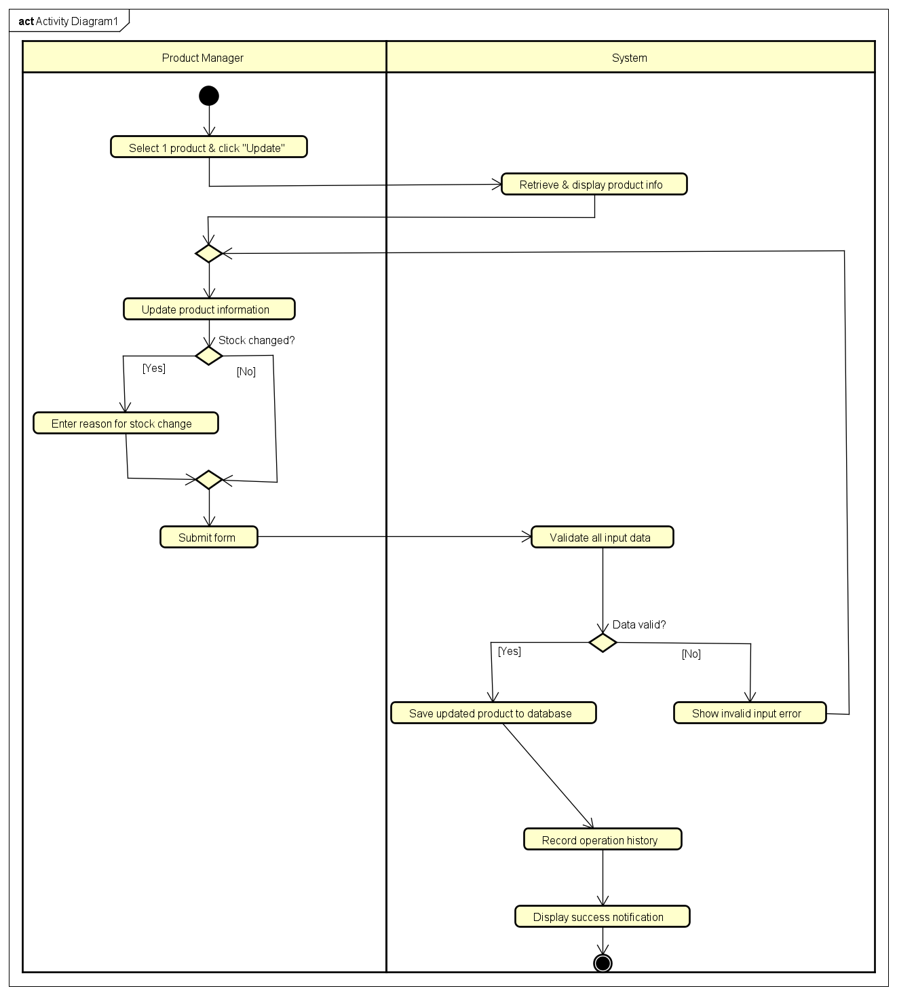

Use Case: Delete Product
1. Use Case Code
UC005-Delete

2. Brief Description
This use case describes the interaction between the Product Manager and the AIMS system when the actor wants to delete one or more products. The system enforces three constraints: no more than 10 products may be selected in a single deletion request; no more than 20 products may be deleted in total per day; and a product can only be permanently deleted if its stock quantity is zero. If a selected product has stock greater than zero, it cannot be deleted — its status is instead changed to 'deactivated', making it unavailable for sale.

3. Actors
Product Manager

4. Preconditions
- The Product Manager has successfully logged in to the system.
- The Product Manager is on the product management screen.
- At least one product exists in the system.

5. Basic Flow of Events
1. The system displays the list of products (active and deactivated) with checkboxes for selection. The UI shows the number of products already deleted today
(e.g., 'Deleted today: 3 / 20').
2. The Product Manager selects one or more products (up to 10 simultaneously) and clicks the Delete button.
3. The system validates that the number of selected products does not exceed 10 (see Alternative Flow A).
4. The system validates that performing this deletion would not cause the Product Manager to exceed the daily limit of 20 deletions (see Alternative Flow B).
5. The system displays a confirmation dialog listing the selected products and their current stock quantities, asking the Product Manager to confirm the deletion.
6. The Product Manager confirms the deletion.
7. For each selected product, the system checks its stock quantity:
- If stock = 0: the product is permanently deleted from the database.
- If stock > 0: the product cannot be deleted. Its status is changed to 'deactivated'. It will no longer appear in any customer-facing product listing.
8. The system records an entry in the product deletion history log for each affected product (action type: deleted or deactivated).
9. The system displays a result summary notification (see Output Data).
10.The product list is refreshed. The use case ends.

6. Alternative Flows
- (A) Simultaneous Selection Limit Exceeded: If the Product Manager selects more than 10 products and clicks Delete (Step 2), the system immediately displays an error message before any deletion is attempted. No products are deleted or deactivated. Resume at Step 2.
- (B) Daily Deletion Limit Exceeded: If the requested deletion would cause the total deletions today to exceed 20 (Step 4), the system rejects the entire request and displays an error indicating how many deletions remain available today. No products are deleted or deactivated. The use case ends.
- (C) Empty Selection: If the Product Manager clicks the Delete button without selecting any product (Step 2), the system displays a message prompting the Product Manager to select at least one product. Resume at Step 2.
- (D) Product Manager Cancels Confirmation: If the Product Manager clicks 'Cancel' on the confirmation dialog (Step 6), no changes are made. Resume at Step 2.

7. Input Data
No | Data Field | Description | Mandatory | Valid Condition | Example
1 | Selected Product(s) (Barcode) | Unique identifiers of the product(s) selected for deletion. | Yes | Must identify existing products in the system.  Selection count: 1 to 10 products.  Total deletions today (including this request) must not exceed 20. | 8935234512345  8935234512346

8. Output Data
No | Data Field | Description | Display Format | Example
1 | Result Summary Notification | Displayed after the operation is processed.  Shows a breakdown: how many products were permanently deleted (stock = 0) and how many were deactivated (stock > 0). | Text message (info banner) | 2 product(s) deleted successfully.  1 product(s) deactivated (stock > 0).
2 | Validation / Error Message | Displayed when a business rule is violated before any deletion is attempted. | Text message (red banner) | Cannot select more than 10 products at a time.  Daily deletion limit reached. You may delete 5 more product(s) today.  Please select at least one product to delete.
3 | Confirmation Dialog Content | Displayed before executing the deletion, listing selected products with their current stock quantities to allow the Product Manager to review. | Modal dialog | Product: One Piece Vol.1 | Stock: 0 → will be DELETED.  Product: Dragon Ball | Stock: 12 → will be DEACTIVATED.

9. Postconditions
- Products with stock = 0 are permanently removed from the system database.
- Products with stock > 0 have their status changed to 'deactivated' and are no longer visible to customers.
- An entry is recorded in the product deletion history log for each affected product (action type, timestamp, Product Manager ID).
- The daily deletion counter for the Product Manager is incremented by the number of products permanently deleted.
- The product list is refreshed to reflect all changes.
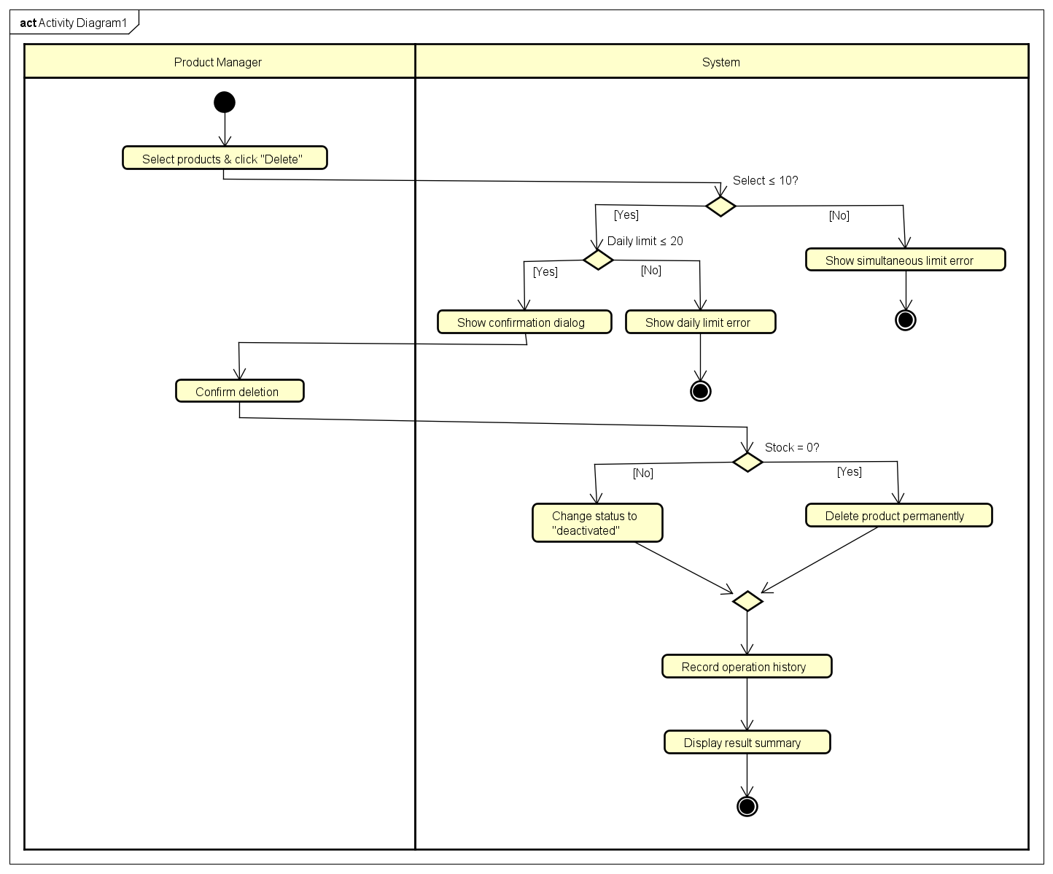

Supplementary specification

Functionality
This subsection outlines general business rules and functional constraints shared across the system:
- Taxation Policy: The system shall automatically calculate and apply a 10% Value-Added Tax (VAT) to the original and current prices of all physical media products. Shipping fees are exempt from VAT.
- Shipping Fee Rules: The system shall dynamically calculate shipping fees based on the total weight and delivery location:
- For Hanoi and Ho Chi Minh City: The base rate is 22,000 VND for the first 3kg.
- For other provinces: The base rate is 30,000 VND for the first 0.5kg.
- Weight Surcharge: An additional 2,500 VND is applied for every subsequent 0.5kg.
- Free Shipping Policy: Orders with a total product value strictly exceeding 100,000 VND shall receive a shipping discount up to a maximum of 25,000 VND.
- Default Payment: The system shall default to the VietQR payment method, while providing PayPal Sandbox (Credit Card) as an alternative option.
- Automated Notifications: The system shall automatically integrate with an Email System to dispatch invoices and transaction receipts upon successful payment or order status updates.

Usability
- Anonymous Checkout: The system must allow Customers to search products, manage their carts, and place orders seamlessly without requiring them to register for an account or log in.
- Dynamic Updates: The checkout interface must dynamically recalculate and display the shipping fee immediately whenever the customer updates the delivery address.
- Error Handling & Recovery: The system shall provide clear, actionable error messages (e.g., "Insufficient Stock," "Invalid Credit Card," "Gateway Timeout") and must allow users to retry actions or return to previous steps without losing their current session data.

Reliability
- Continuous Operation: The system must be highly reliable and capable of operating continuously for at least 300 hours without any critical failures or required downtime and can run at least 1 hour after incident.
- Availability: As an e-commerce platform, the system shall maintain 24/7 availability for customer-facing modules.
- Transaction Integrity: In the event of a payment gateway timeout or network failure, the system must not drop the user's session. It shall safely abort the transaction, notify the customer, and retain the shopping cart data for a retry.

Performance
- Concurrent Users: The system architecture must be robust enough to support up to 1,000 customers accessing and browsing the store simultaneously without significant performance degradation.
- Response Time: The system shall ensure a maximum response time of 2 seconds in normal hours and 5 seconds in peak hours.

Supportability
- Modular Payment Integration: The payment processing module must be designed with loose coupling to allow easy integration of additional payment gateways (e.g., Momo, ZaloPay, domestic bank cards) in future iterations.
- Extensible Catalog: The database schema for physical media (Books, CDs, DVDs, Newspapers) should utilize inheritance (e.g., a base Media class) to easily support new product types or digital downloads later.

Other requirements
- Security & Access Control: The administrative portal must enforce Role-Based Access Control (RBAC). Only authenticated Users can access internal features, and specific actions (like user management) are strictly restricted to Administrators.
- External API Dependency: The system relies on the availability of the external PayPal Sandbox API and VietQR API.

